Pipelining
Pipelining is a technique of decomposing a sequential process into suboperations, with each subprocess being executed in a special dedicated segment that operates concurrently with all other segments.

Instruction Pipeline
Pipeline processing can occur not only in the data stream but in the instruction as well.
Consider a computer with an instruction fetch unit and an instruction execution unit designed to provide a two-segment pipeline.
Computers with complex instructions require other phases in addition to above phases to process an instruction completely.
In the most general case, the computer needs to process each instruction with the following sequence of steps.
- Fetch the instruction from memory.
- Decode the instruction.
- Calculate the effective address.
- Fetch the operands from memory.
- Execute the instruction.
- Store the result in the proper place.

Example: Four-Segment Instruction Pipeline

Assume that:
The decoding of the instruction can be combined with the calculation of the effective address into one segment.
The instruction execution and storing of the result can be combined into one segment.
Thus, the sequence of steps reduces to four segment steps as:
FI: the segment that fetches an instruction
DA: the segment that decodes the instruction and calculate the effective address
FO: the segment that fetches the operand
EX: the segment that executes the instruction

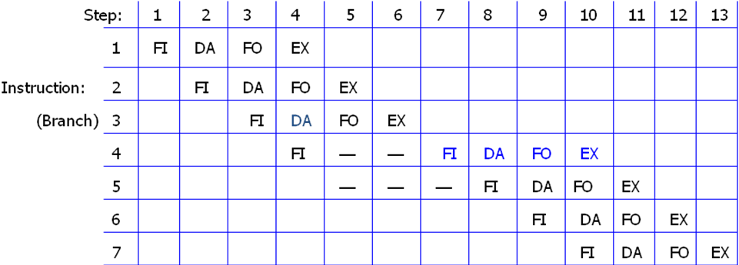

Fig 4-8: Timing of Instruction Pipeline
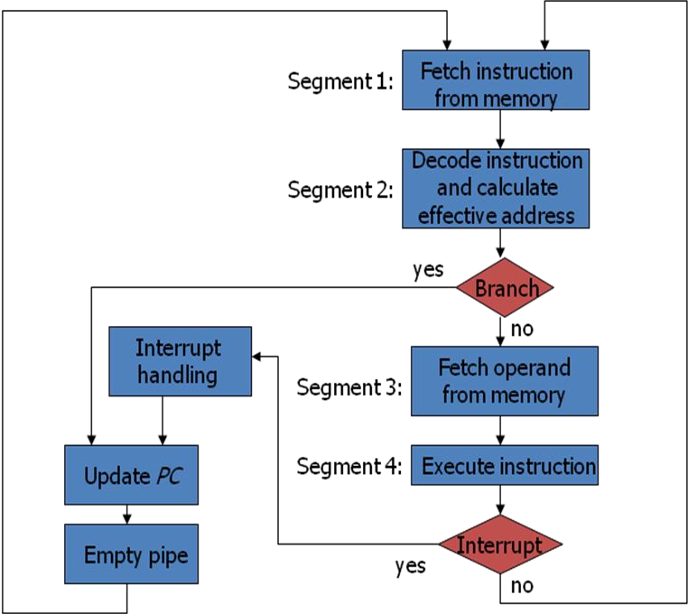

Fig 4-7: Four-segment CPU pipeline

